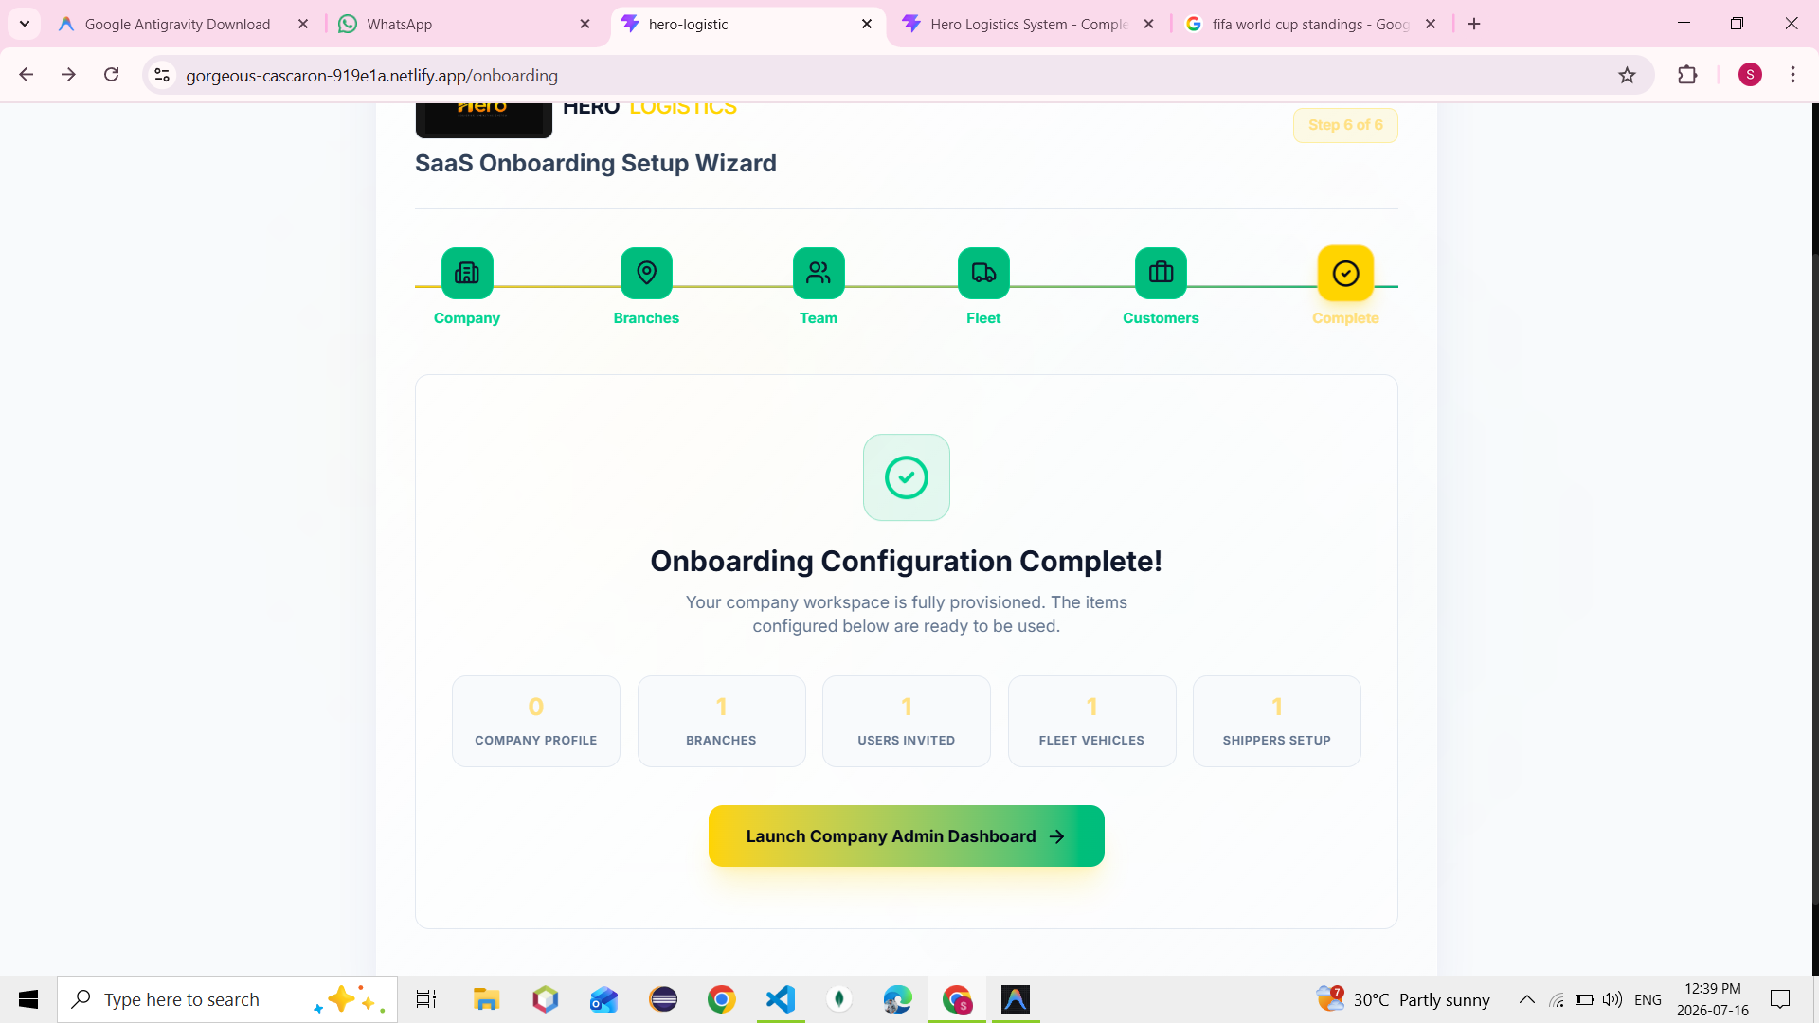

Launch dashboard to Click and user interface is not show and click launch dashboard and show the Dashboard. Routes is not working
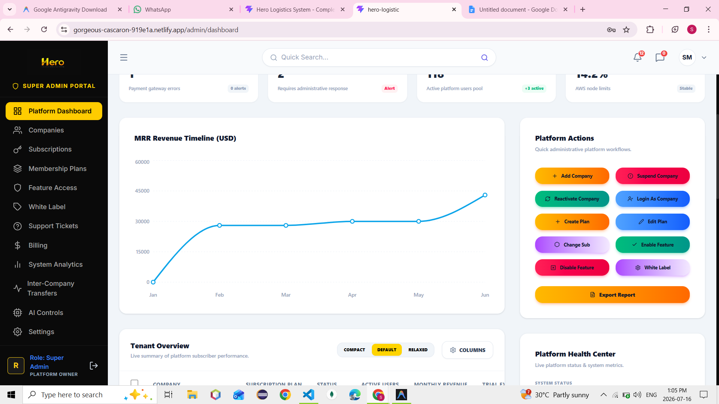
Export Report is not work
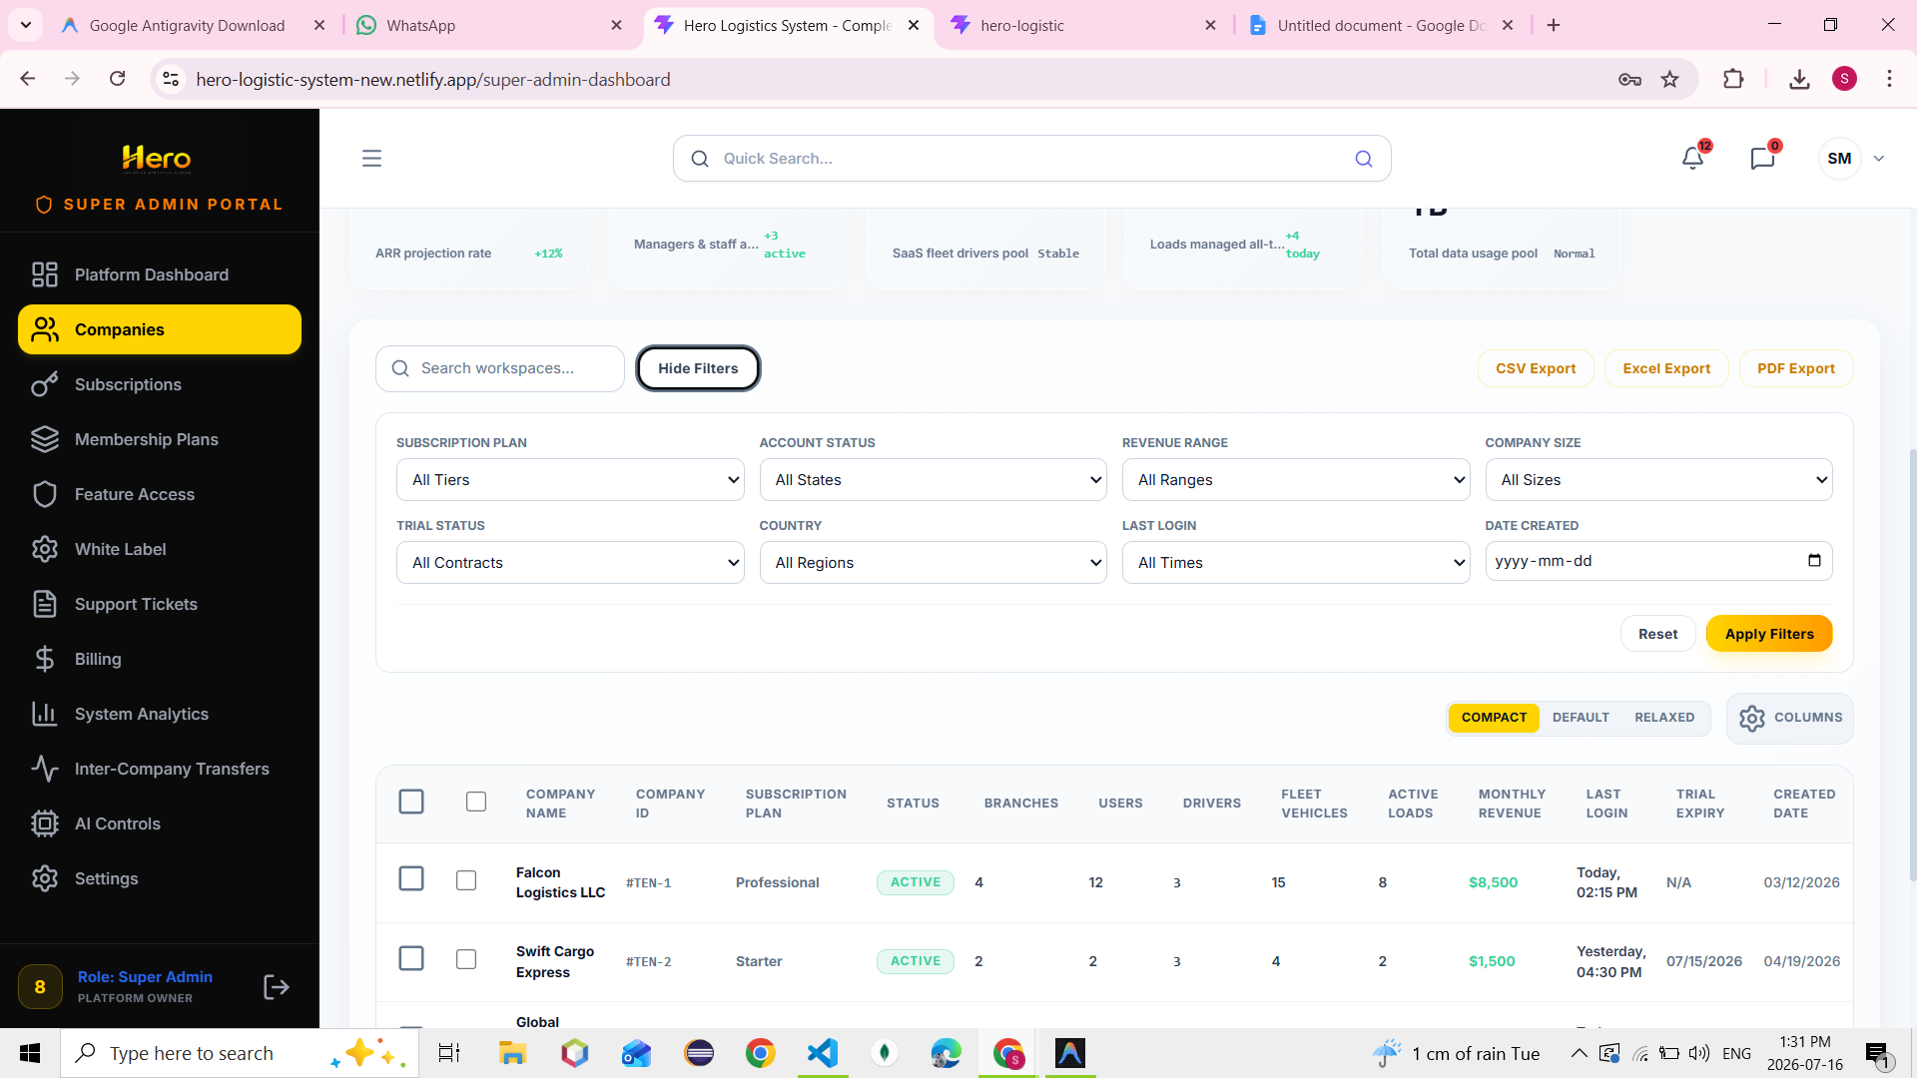

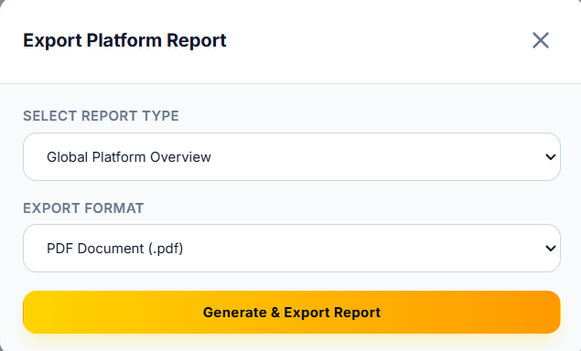
Export report click popup is show to fixed the problem
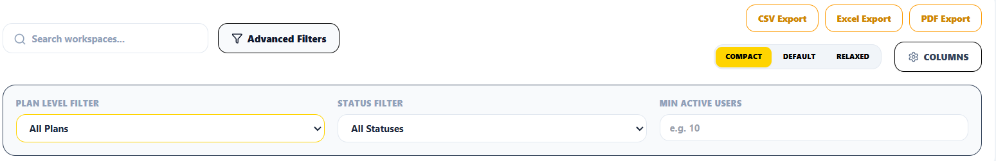
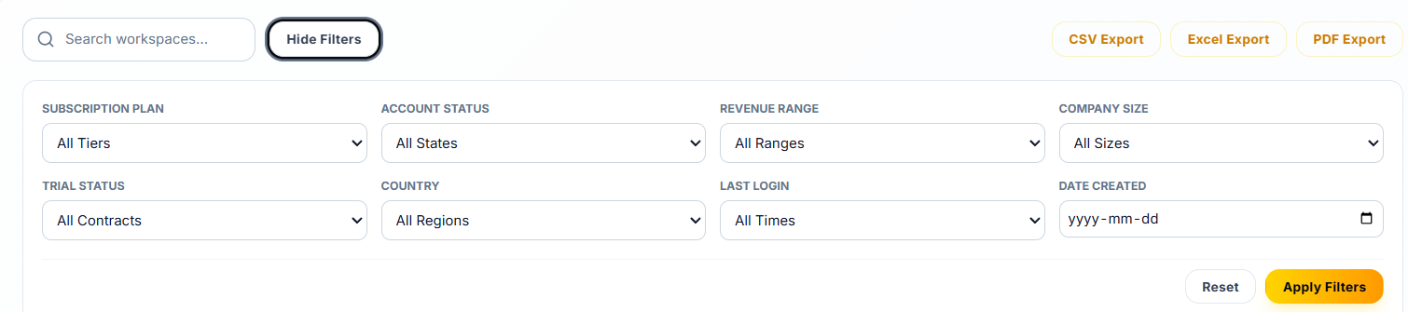
Uper wale me kuch filter nhi h but nicche wale me h to uper wale filter me add kar do jo nicche filter h
Overage billing is not show or all popup are show
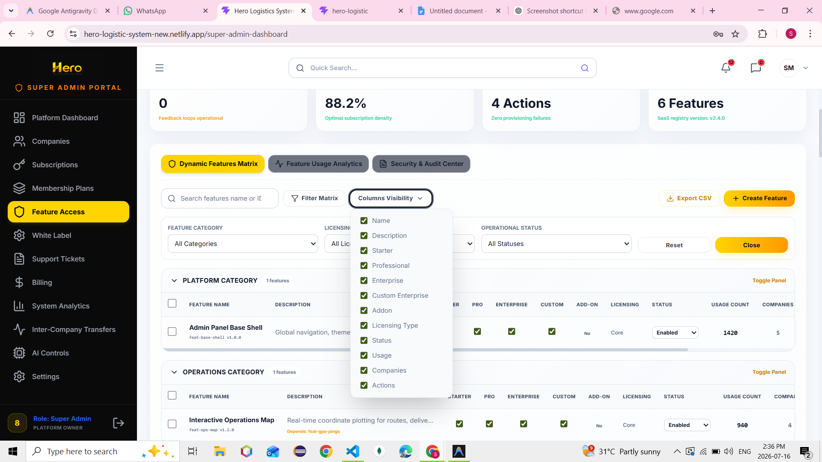
is me filter matrix or columns visibility me popup show ho rha h
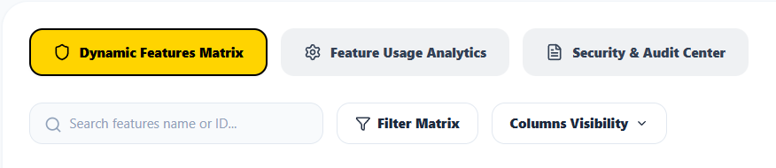
Isme filter or columns visibility me popup nhi show ho rha h isko fixed karna h
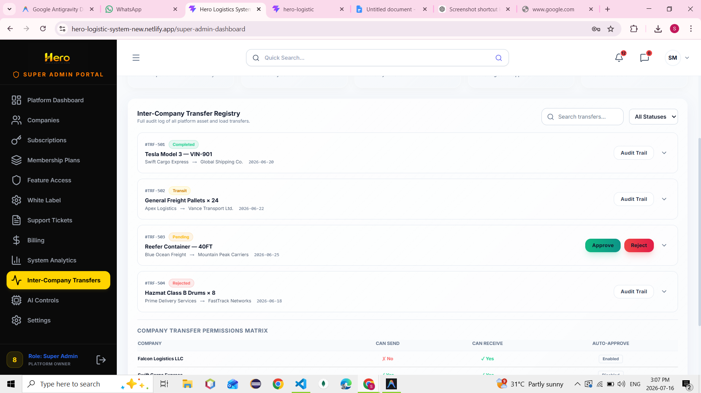

Isme ye aduit trail work kar raha h popup show bhi kar raha h
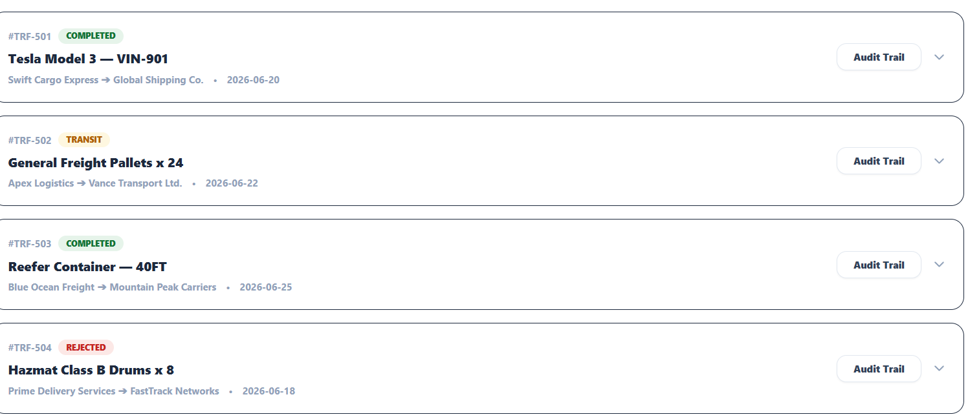
Isme ye aduit trail work nhi kar raha h is problem ko fix karo
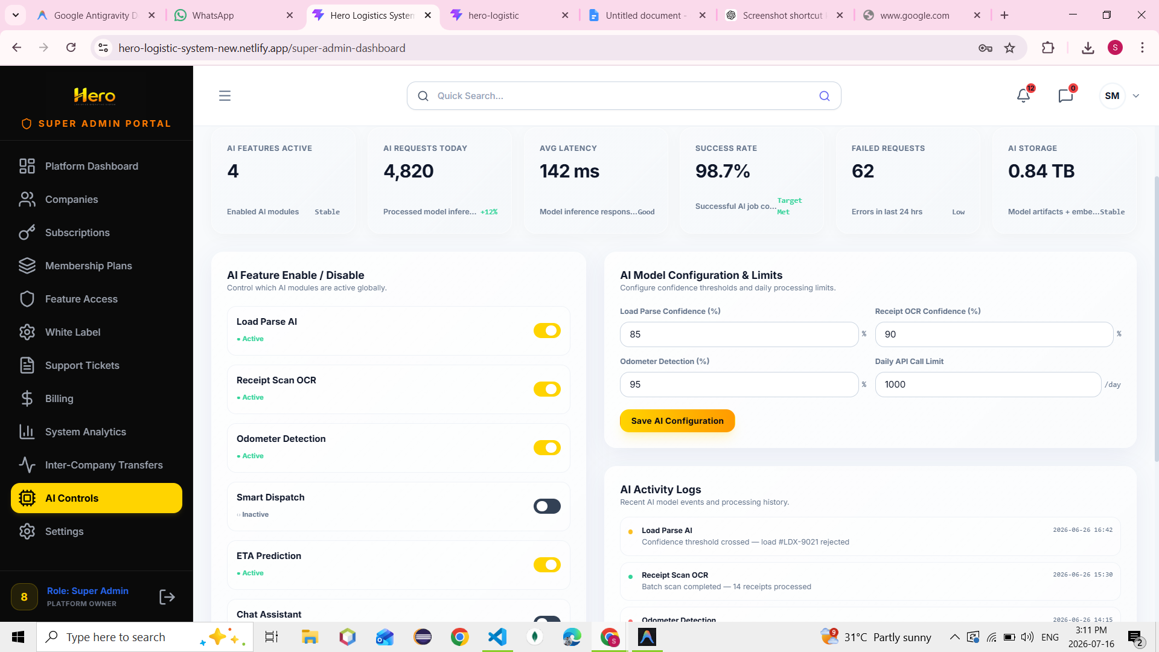
Save Ai configuration is working save successfully ho rha h h
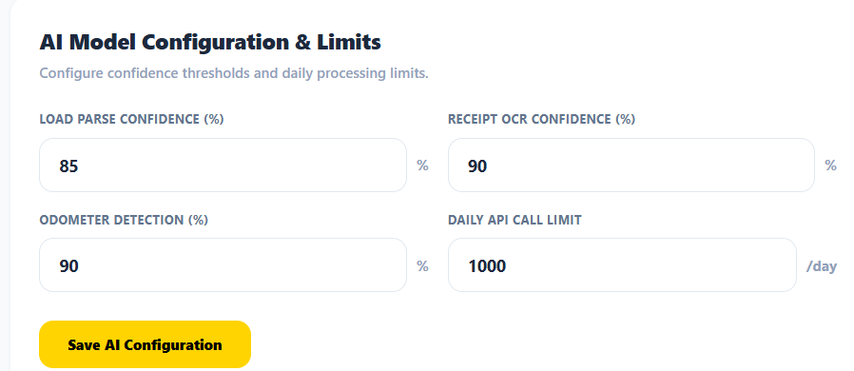
Isme Save Ai configuration is not working successfully save nhi ho rha h
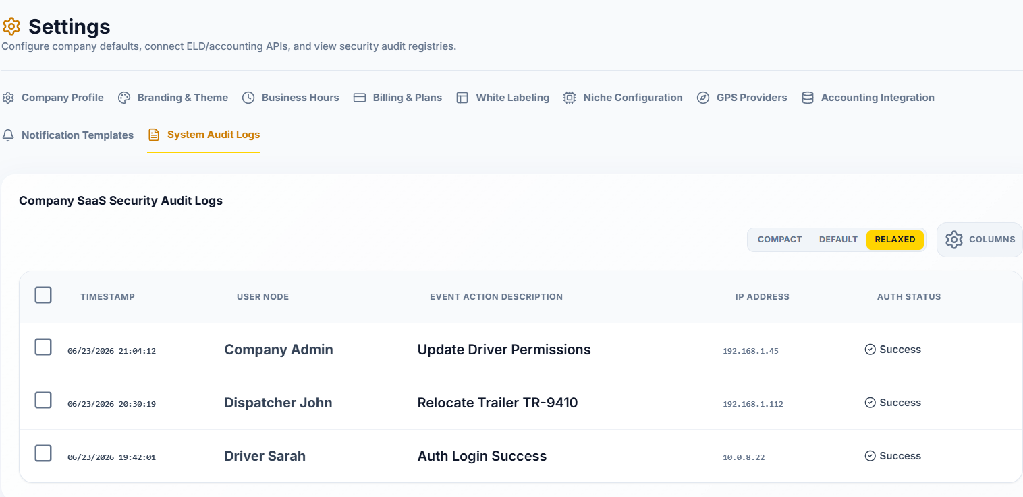
Isme compact , default , relaxed is working
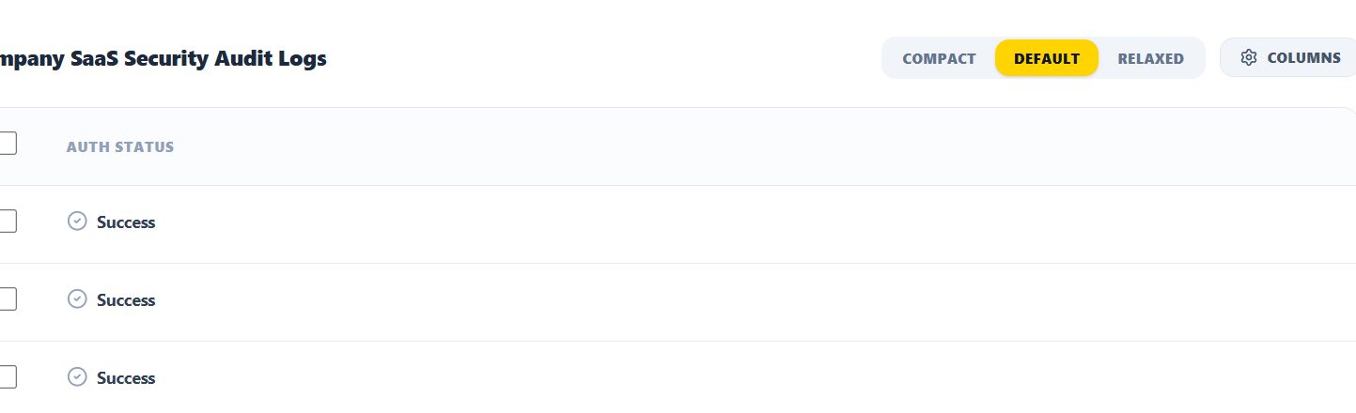
Isme compact, default , relaxed,columns working nhi kar rahe h

Sales Dashboard
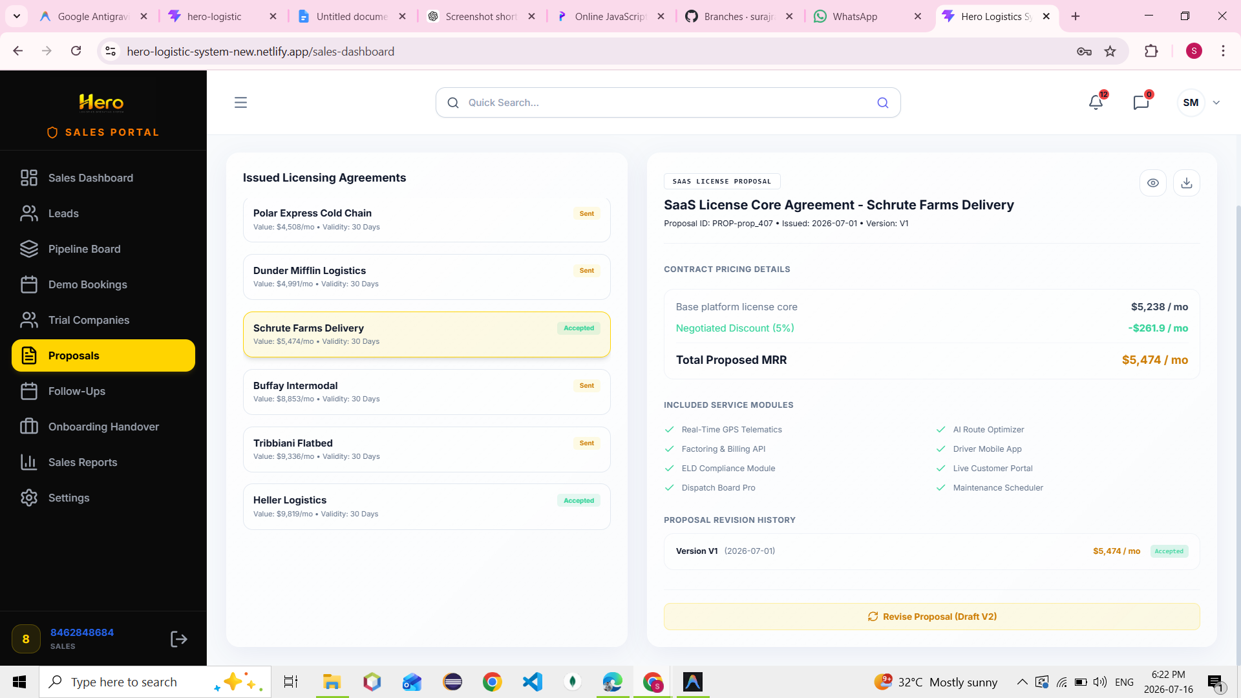
Revise proposal isme work kar raha h
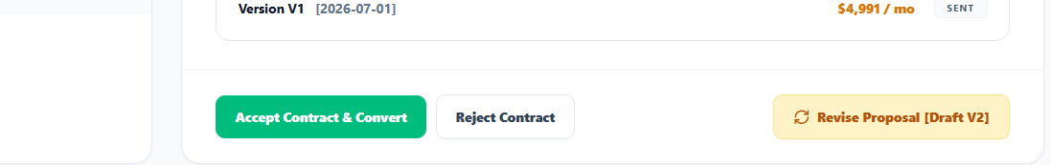
Isme work nhi kar raha h revise proposal

